MACHINE LEARNING
INTRODUCTION TO MACHINE LEARNING



KHEN MUHAMMAD CAHYO
244107023002
TI-3I
STATE POLYTECHNIC OF MALANG
INFORMATION TECHNOLOGY DEPARTMENT

LAB ASSIGNMENT 1 – PART 1
- Create a Notebook
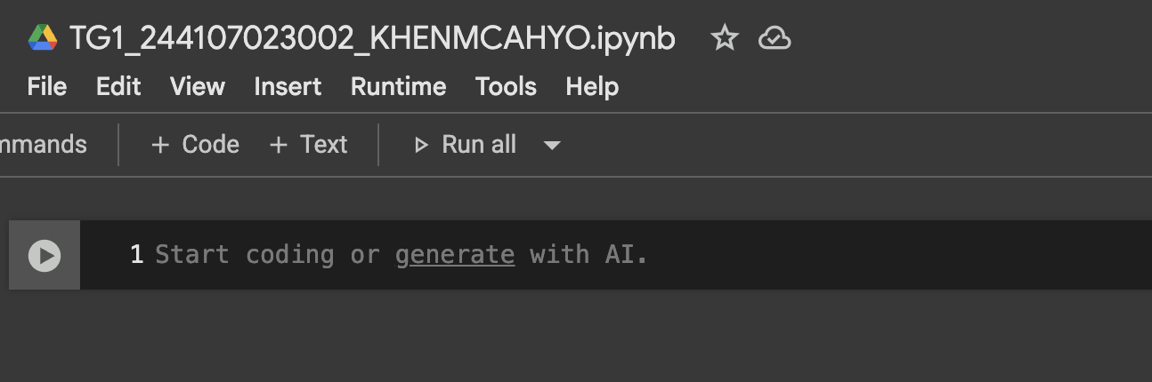
- Install Following Libraries
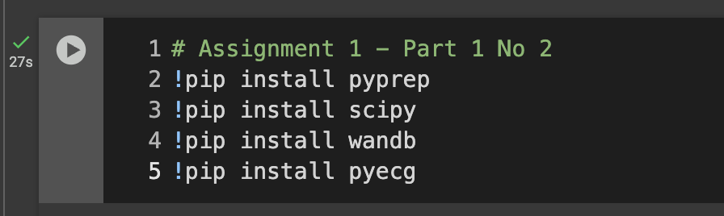
- Libraries Explanation
PyPREP is a Python implementation of the PREP pipeline, originally designed for EEG preprocessing. It is mainly used to clean EEG (electroencephalography) signals by automatically detecting and removing noisy channels, referencing signals, and reducing artifacts without manual intervention. Researchers use PyPREP to streamline preprocessing in neuroscience and biomedical signal processing, ensuring cleaner input data for subsequent analysis or machine learning.
SciPy is a fundamental Python library for scientific and technical computing, built on top of NumPy. It provides efficient algorithms and functions for linear algebra, optimization, integration, interpolation, signal processing, statistics, and more. Widely used in research and engineering, SciPy allows users to perform complex mathematical computations with optimized performance, making it essential for data analysis, numerical simulations, and scientific applications.
Weights & Biases, often imported as wandb, is a tool for experiment tracking, model monitoring, and collaboration in machine learning projects. It helps researchers and developers log metrics, visualize training progress in real-time, manage hyperparameters, and compare different runs. In addition, wandb integrates seamlessly with popular frameworks like PyTorch and TensorFlow, making it a popular choice for reproducible ML workflows and team collaboration.
pyECG is a Python library designed for processing and analyzing ECG (electrocardiogram) signals. It provides functions for tasks such as filtering raw ECG data, detecting R-peaks, measuring heart rate variability (HRV), and extracting other clinically relevant features. Researchers and healthcare developers use pyECG to build applications for cardiac signal monitoring, diagnosis support, and biomedical research.

LAB ASSIGNMENT 1 – PART 2
Answer Number 1
- Ghibli Style
At the beginning of this year, social media was abuzz with the popular use of the Ghibli style by artificial intelligence (such as Gemini, GPT-4O, etc.), and many people took advantage of this moment to transform their photos into the Ghibli style. The creator of the Ghibli style, Hayao Mazaki, criticized the use of his Ghibli style and admitted that he strongly dislikes AI, stating that he would never use AI in his field.
- Kumparan References
- UMS References
- Deepfake
I think there is a lot of deepfake content now, especially since artificial intelligence (AI) has become popular. For example, some Indonesian content creators such as Dr. Tirta or Willie Salim have had their faces used to promote online gambling. And some Korean or Western female artists have had their faces used for pornographic content.
- Wikipedia Deepfake References
Answer Number 2
- Energy Consumption & Carbon Footprint
Data centers that support AI are extremely energy-intensive. Currently, data centers account for approximately 1–2% of global electricity consumption, and demand could grow by up to 160% by 2030.
Indirect emissions (Scope 2 & 3) from large technology companies such as Amazon, Microsoft, Alphabet, and Meta increased by 150% between 2020–2023, with potential emissions of up to 102.6 million tons of CO₂ per year.
- USC References
- Reuters References

- Use of Water for Cooling
AI and data centers create significant cooling needs: it is estimated that global AI will consume 4.2–6.6 billion m³ of water per year by 2027—more than the total annual water withdrawal of half of the United Kingdom or the entire country of Denmark. A single 100 MW data center can use up to 2 million liters of water per day, equivalent to the daily needs of 6,500 households.
- USC References
- Wikipedia References

